Professional Portfolio

Name: ____________________________

Date: ________________

Section A: Career Action Plan
A Career Action Plan helps you to focus on your goals and plans for the future. It helps you to work out how you are going to achieve what you want relating to study, work and life. A Career Action Plan lets you work out your career capabilities and how they relate to your preferred career option.

Part 1: My profile
Summarise your self-assessment
If you have completed the quizzes in Module 1 you can return to them to help with this section. These sections of your action plan mirror the questions asked in these quizzes and in Assignment 1.
My greatest strength and biggest weakness | - Strength: Organisational Skills. Organizational skills have been defined as “the skills you use to organize your workload, manage time, resources, and schedule and prioritize projects” (H, 2019). This implies the ability to coordinate works, the available human resource and teams efficiently. This will allow the team that I would be supervising to stay on track on what is to be done and to execute the same within the stipulated time and provide quality deliverables.  - Weakness: I sometimes lack confidence; I could use more experience in Construction Management. This is an area of major concern because as a team leader I would be expected to command and inspire a following and this cannot be actualized without self-confidence.
What I value in the workplace | - Accountability. This is because accountability is the first step at creating trust between the employers and their employees. With established trust in the workplace then the employees will be in a better position to work to their full potential without fear of their actions being suspected at all times. This will help improve the organization’s performance, help to promote ownership in that the employees will learn to value their work, and as a result be able to inspire confidence in the team members (Adeola, 2019).  - Honesty: This is an important characteristic to establish in a business as it has the potential to set the tone for the kind of work culture that you would want to create in an organization. It helps to provide consistency in the workplace behaviour and to build loyalty and trust in customers and other business prospects (Quain, 2019).
What I am passionate about | - Construction Industry: I have dedicated enormous amount of time in the development of my career as a construction manager given my passion to want to come to assume such a position in a construction company.  - Building and accomplishing projects: It is my passion to put my designing and organizational skills to practice by way of seeing to it that construction projects have been executed and with such prowess as to warrant the reception of appreciation awards as did the monumental buildings by great artists.  - Working for a great team/company: It is my goal to one day secure a construction manager job position in one of the great construction companies and with it come to work for and with a great team within such a great organization. It is the driving force behind my desire to achieve greatness and to do so among the great and renowned construction companies around the globe.
My top three work/life priorities | - Keeping myself honest: As much as I value honesty and accountability in any workplace, I strive to be equally honest and accountable for my actions in my everyday life and with it develop this culture in myself that I could easily demonstrate and radiate it to my team members as I come to assume the construction manager job position in my career path.  - Staying up-to date: The world today is highly dynamic in that there is a lot of things coming up that have the potential of changing the way things function entirely in any field. It is, therefore, for this reason that I mainly engage in a lot more reading of upcoming literature so that I can easily keep up with the changing trends so as to be in a better position to execute my duties as an updated construction manager.
The top three employability skills I bring to the workplace | - Subject matter expertise: I have done a lot more in terms career development by way of acquiring the necessary skills in matters construction management to make me exceptionally qualified to handle this task efficiently.  - System analysis: I have majored on system analysis as the main tool to use in troubleshooting for any threats to the project being executed and with it I believe I would be in a better position to foresee any threats and make amendments in the current design to cater for these short falls before they cost the organization a lot more in repair and corrections.  - Planning: I believe that my ability to efficiently plan for a project and manage it efficiently places me in a better position to execute the responsibilities of a construction manager.

Part 2: My future
Summarise your research into your ideal job
The information in this section of your plan is a summary of the research you compiled in Assignment 2: Research report
Ideal Job profile | Brief summary of your ideal job. What is the job? What does a person in this role do? What are the prospects in your ideal job- salary, working hours, career development? What is the future of this industry and occupation- labour market trends, employment opportunities, growth potential  A construction manager job involves the planning and budgeting for, coordination, and supervision of construction projects from the initial stages of development to completion. They oversee and manage specialized personnel and the human resource necessary in the construction process. Construction managers manage variety of building and construction projects from commercial, residential, public, and industrial structures and roads, and bridges.  Construction managers;  - Interpret and explain technical information and architectural drawings.  - Prepare and manage cost estimates and construction budgets.  - Respond promptly to work emergencies and project delays.  - Ensure compliance with safety codes, legal requirements, and other building regulations.  - Manage labour resources.  - Hire sub-contractors and workers.  - Collaborate with architects, engineers and other personnel to ensure timely project completion and avoid budget constraints.  - Select the construction materials required in projects.  - Secure certifications and permits for projects.  Over the last 5 years, employment in the construction industry has increased by 19.6%. The Construction Outlook survey, 2019 predicted a 4.4% rate of increase of employment in the construction industry and a 2.4% growth in the entire industry. The report stated that “…expansion of the workforce will be highest among subcontract tradesmen (+5.8%) and on-site employees (+3.1%). However, off-site employment is expected to contract slightly by 0.8% in the first half of next year” (Anon., 2019).  The demand of construction managers, since they are part of the on-site project workforce, is expected to be on the rise. According to the Job Outlook, the construction industry will have an estimated 54,000 construction managers job openings over the next five years which will translate to 10,800 job openings on a yearly basis. In addition, construction managers earn on average $112,204 per year with an hourly rate of roughly $ 38, this is expected to rise to over $150,000 on average.

Key attributes
(e.g. personal characteristics such as personal presentation and motivation)
Key skills  (e.g. technical, academic and employability skills) | I would like to consider myself as possessing the highest subject matter expertise in construction management, with enough skills to competently carry out any system analysis with impeccable panning skills in terms of planning for construction projects and in overseeing its execution.

Part 3: My Plan
Goals are things that you want to achieve in the future. They are things that will help you to be prepared and ready for change at university or in your life. It is important that you think about goals early because then you can work out how to achieve them. Thinking about goals means that you will be prepared to study the subjects you like, do the types of occupations you prefer, and keep your future options open. If you meet a goal throughout the year, set another new one for yourself – maybe a more challenging one.

1. My Career SWOT
Reflect at where you are currently in your career and brainstorm the strengths, weaknesses opportunities and threats in your position.

Strengths | Weaknesses
- Intellectual growth- I am being nourished intellectually to become the construction manager I look forward to.  - Career advancement- after completing my studies, I am likely to be awarded a job immediately.  - Leadership- I have developed good leadership skills that will be useful in my position as a construction manager | - Insufficient branding- I have not yet developed a perfect personal brand based on my career prospects  - Lack of confidence-it limits my search for knowledge on construction. I am not able to approach my role models for career guidance
Opportunities | Threats
- As a student I have a chance to learn more about my career by volunteering in different firms during the holidays  - My internship also presents an opportunity for me to learn more about my profession  - Being a student also gives me an opportunity to interact with fellow students, challenge each other and even exchange our knowledge on construction matters | - Competition- since we are several students studying the same course, there is a likelihood of competition for jobs  - Brand quality-in case I will not have branded myself well more than my competitors, I will be disadvantaged

2. My SMART goals
Create one goal each for 6 months, 12 months and 5 years
Current goal:
To complete my professional portfolio in a way that warrants the achievements of my goals.
For the time period: 6 months – Gain some experience in the construction industry.

Objectives | Support/Resources required | Potential barriers/difficulties | Problem solving strategies | Review date
To secure a job position in a construction company working as their construction manager. | Recommendation letters from the university that I attended for my undergraduate degree and from my previous employers. | The lack of enough job opportunities that is currently open for construction managers. | To assume an optimistic attitude in my search or job opportunities to ensure that I do not give up before achieving my goals. | By the end of the day 11th June, 2020.

Current goal: Gain some experience in the construction industry. __________________________________________________________________________________
For the time period: 12 months

Objectives | Support/Resources required | Potential barriers/difficulties | Problem solving strategies | Review date
To expand my skills set in terms of execution of my responsibilities as a construction manager. | I would require full support from my assigned team to ensure that I fully explore my potential in my set position. | Insubordination by the team members working under authority. | Dedicate time to teambuilding exercises as a means to ensure that the other team members feel appreciated and recognised as equal members of the team. | End of day 11th Dec, 2020

Current goal: Expand my skill set in matters construction management. ____________________________________________________________________________________
For the time period: 5 years

Objectives | Support/Resources required | Potential barriers/difficulties | Problem solving strategies | Review date
To have made advancement in my career by achieving a master’s degree in construction management. | I would require financial support in terms of scholarships to a renowned university to further my education, a library subscription to easily acquire reading material that I would require and study leave from work. | Lack of financial support.  Inability to enrol into a program in good time.  Lack of sufficient time to take my studies. | Begin looking for sponsorships early enough.  Begin searching for competent programs to enrol in early enough. | By end of day, 11th Dec, 2025

Resources I need to help me achieve these goals

Sources of information  (e.g. my future, Job Guide, career websites) | Websites involved in the advertisement of job opportunities.  Scholarship opportunities as advertised online and/or via newsletters or newspapers.
Who can help me  (E.g. friends, family, careers practitioners etc.) | The individuals in a better position to give an assist are my employers in terms of according me a study leave, my friends in helping me secure a scholarship and my family members in terms of ensuring that I have all that I need to embark on this enticing journey.

3. My skill development plan

Review the level of skills, attributes and qualifications you need for your ideal job against your current levels. Identify where you may need further development and outline a basic plan for how you will achieve this and by when.

Areas I need to develop to achieve my ideal job

Attribute to develop  (i.e. personal characteristics such as personal presentation and motivation that are highly prized in your ideal job) | How? | By when
Level of organization | Practicing proper organizational skills | By the time I assume office
Aspects of creativity | By noting down ideas as they arise and working towards developing them into material aspects of construction. | By the time I assume office
Confidence | By engaging to motivational talks about building around one’s self confidence. | By the time I assume office

Job specific skills to develop  (technical., academic and employability skills specific to your ideal job) | How? | By when
Planning skills | By putting my planning skills into practice to foster growth and development of the same | By the time I get to manage a project at work.
Systems analysis | By engaging with a lot more materials and literature on system analysis | By the time I come to spearhead a practical system analysis.
Team management skills | By engaging in tutorials and trainings on team management. | By the time I come to have a team assigned to me as a construction manager.

Qualifications I need | How? | By when
Degree in the specified area. | By taking up an undergraduate degree in construction management | Before I even begin applying for jobs.
Master degree in construction management and/or project management | By taking up/ enrolling into master programs in designated renowned universities. | By the time am two years into employment.

Section B: Career Toolkit

Name: ____________________________ Date: ________________
Part 4: Sample job advertisement
Copy and paste into this box the job advertisement that you will be targeting this career toolkit to.
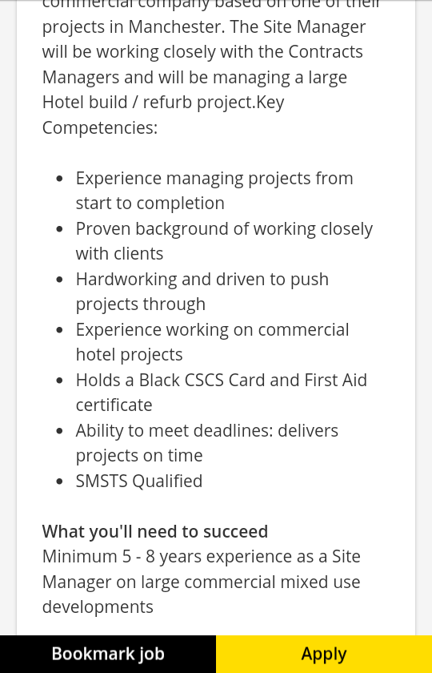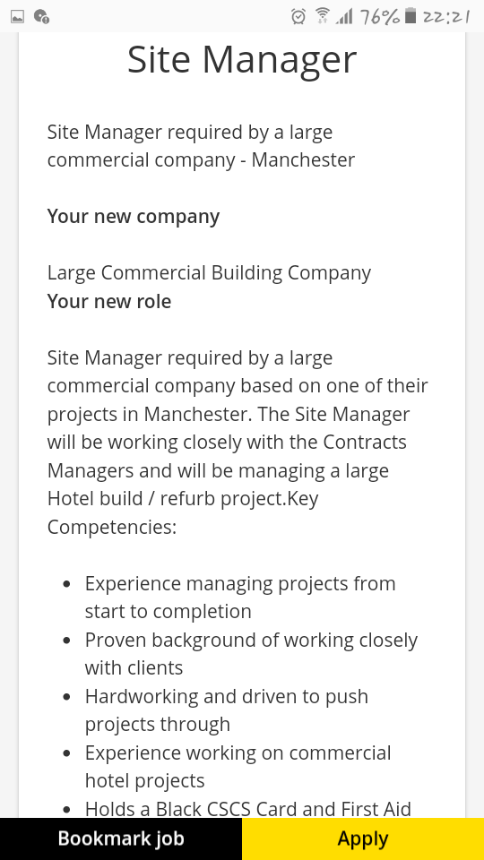

Part 5: Sample cover letter
Write a 300 word cover letter in response to the job advertisement in Section A. Write your cover letter as if you have achieved the goals you set for yourself in Assignment 3 Part 2.
Name
Phone Number
Email address
December 11, 2019
Dear Hiring Manager,
I was especially excited to come across the advertisement that your office made for the position of a construction manager at Large Commercial Building company. I have been specifically active in matters construction management in the past few years and during that time I have greatly participated in a number of projects, including one at Giovenco Ltd where I was fortunate enough to lead a team working on the APLNG construction project. I would like to think of myself as having achieved the basic qualification for competently taking up this job position. In my previous hire, I have been praised for my ability to handle team projects competently and especially with impeccable planning skills, excellent system analysis to foreseeing potential problems and in being instrumental to ensure that proactive corrective plans have been instituted.
In my previous role as a construction manager, I was responsible for ensuring that the team projects assigned to my wing were executed correctly and in line with the stipulated client’s objectives. I was also involved in the management and direction of the instrumental team involved with the maintenance and upgrading of building materials require for that project to ensure that the building’s longietivity and stability was enhanced in addition to the overall human resource management.
I am not only about team and project management but I also pride myself in my ability to pay attention to details when it comes to crafting up plans for major constructions with specific interest on design and quality of materials used. I am also specifically attentive to all kinds of criticism that seek to help improve a design being contended on. In addition, I really value timely feedback as an instrumental factor in ensuring that projects run more smoothly. I am known to maintain and uphold professional interrelations both at work and with all business contacts.
I sincerely look forward to further discussing the role of a construction manager at your company offices. I am optimistic that I would hear back from you in the foreseeable future. I appreciate your time in considering me for this position.
Sincerely,
Name.

Part 6: LinkedIn profile
Your Name: LinkedIn Profile
This template helps you complete a LinkedIn profile (www.linkedin.com) by presenting your CV information in the format of a LinkedIn profile. You do not need to create a LinkedIn profile or include a link to your profile for this assignment.

BASIC INFORMATION
Name:
Address:
Professional headline:
Your headline gives you a way to sum up your professional “identity” in a short phrase. When you create your account, LinkedIn provides a headline for you, but your own headline will be much more effective.
Industry:
Select an industry that most closely matches your experience or the industry you’d like to work in.

SUMMARY
Professional Experience & Goals:
This should give a brief description of what you have done, what you are doing, and the kinds of things you are interested in.
EXPERIENCE
Summarise your three most recent positions
INTERESTS
This field should include a few particular things that you are interested in professionally or personally.
RECOMMENDATIONS
Identify two people in your network that you would approach to write recommendations for you and why you chose them.

Part 7: Sample interview responses
Question 1: What is your biggest strength? _______________________________________________________
Response: I would like to think the biggest strength that qualifies me for this position is my organizational skills. It is an important skill that I acquired as part of my training. I consider it as my biggest strength as it proved effective in helping me execute my duties as an intern in the company that I was posted for attachment.
Question 2: Where do you see yourself in five years?
_______________________________________________________
Response: I imagine that I will be an established construction manager in this organization with an acquired master’s degree and an extended certified project management qualification and positioned better to competently execute my responsibilities.

Part 8: Elevator pitch
Write an 80-150 word ‘elevator’ pitch that is targeted to the job advertisement in Section A.
Name:
College you graduated from:
Degree:
Career goals: My career goal to be a renowned construction manager in firm that offers me enough opportunities for self-growth and development.
Experience: (Who you have worked/interned for in the past)
What I offer: I offer competent organizational skills to the organization with key focus on planning, system analysis and team management. This will be instrumental in helping the organization to function efficiently with timely completion of projects accompanied by quality deliverables that stand to earn the organization a fortune.

Include the link to your 60 second video of you delivering your elevator pitch here.
Part 9: Reflection
In conclusion, I would like to think of myself as a well-behaved and self-driven individual with the necessary skills to warrant my proficiency as a renowned construction manager. I am dedicated in my work, a hard working individual driven by the sole aim of excelling in everything that I do and especially in matter my career as a construction manager. I am well trained in my field of study with great ambitions to scale the heights towards my career development and growth as a construction manager. I will be equipping the work place with key organizational skills to coordinate works, individuals and teams efficiently. This will help the organization to be systematic and efficient in achieving its set goals.

Part 10: Reference list
Adeola, D., 2019. Leading Like a Champion. [Online]
Available at: https://leadinglikeachampion.com
[Accessed 13 December 2019].
Anon., 2019. Industry Outlook 2019-20. [Online]
Available at: CSQ-Industry_Outlook_2019-20.pdf
[Accessed 13 December 2019].
H, M., 2019. Career Trend. [Online]
Available at: https://careertrend.com/facts-6742801-definition-organizational-skills-html.15_November_2019
[Accessed 13 December 2019].
Quain, S., 2019. Chron. [Online]
Available at: https://smallbusiness.chron.com
[Accessed 13 December 2019].

